**PWSkills Assignment 01**

**(Done By: Sunandan Sharma)**

**1.** The HTML code to display the heading "HTML defines the content and structure of your website” on the web browser is as follows.

**The Code:**

<!DOCTYPE html>

<html lang="en">

<head><meta charset="utf-8"><meta name="viewport" content="width=device-width, initial-scale=1.0">

</head><head><title>

Assignment 1 - Question 1

</title>

</head><body>

<h1>HTML defines the content and structure of your website</h1>

</body></html>

**The Output:**

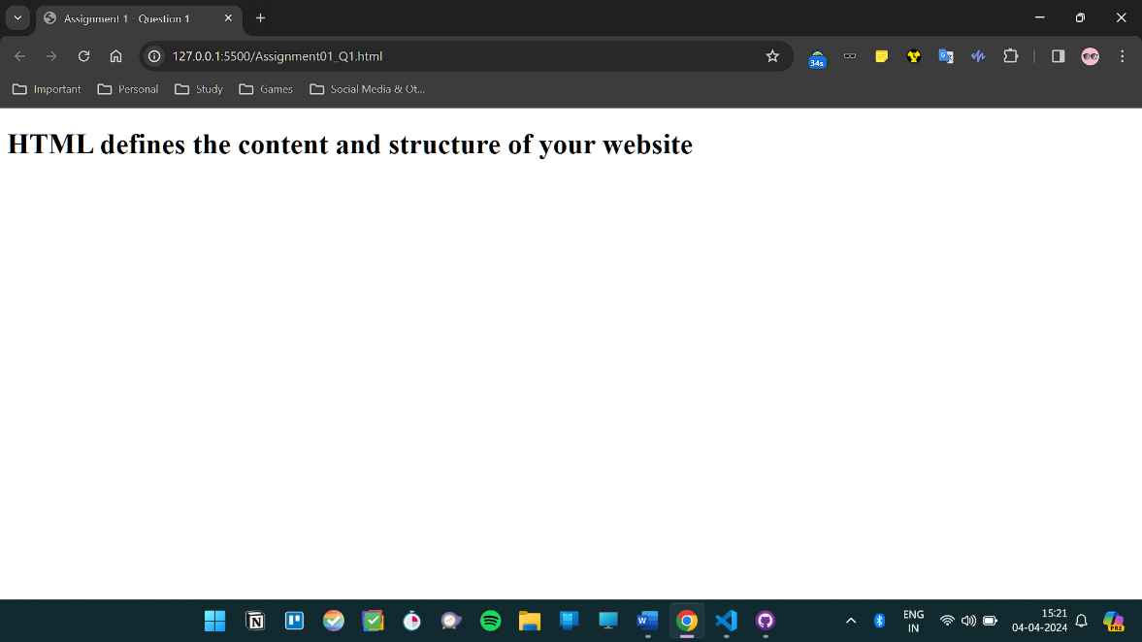

**Code GitHub link:** [**Assignment 01 - Q1 Link**](https://github.com/Sunandanshrm/Web-Development/blob/master/Frontend/PwSkills/Assignment%2001/Assignment01_Q1.html)

**2.** Comments in HTML (or any other programming language) serves the following purposes:

**Code Documentation:** Comments written inside the code provide information about the code’s functionality, purpose, and usage. This helps developers (the original author and others) to understand the utility of existing codebase so it can be maintained properly. This also provides clarity and readability to all the developers working on the same project.

**Code** **Debugging:** Comments are sometimes use to temporarily disable some portion of the code without totally deleting it. This helps especially during debugging a lengthy codebase as it is easier to isolate individual section of the code and modify it.

**Collaboration:** Comments can be used to facilitate collaboration among team members working on the same project. They enable developers to communicate ideas, suggestions (Say a link to a blog or tutorial which has relevance to project), or concerns about specific code segments, leading to better teamwork and code quality.

Following is the example of a HTML code with comment added in it.

**The Code:**

<!DOCTYPE html>

<html lang="en">

<head><meta charset="utf-8"><meta name="viewport" content="width=device-width, initial-scale=1.0">

</head><head><title>

Assignment 1 - Question 2

</title>

</head><body>

<h1>HTML defines the content and structure of your website</h1>

<!--This is a comment here-->

</body></html>

**The Output:**

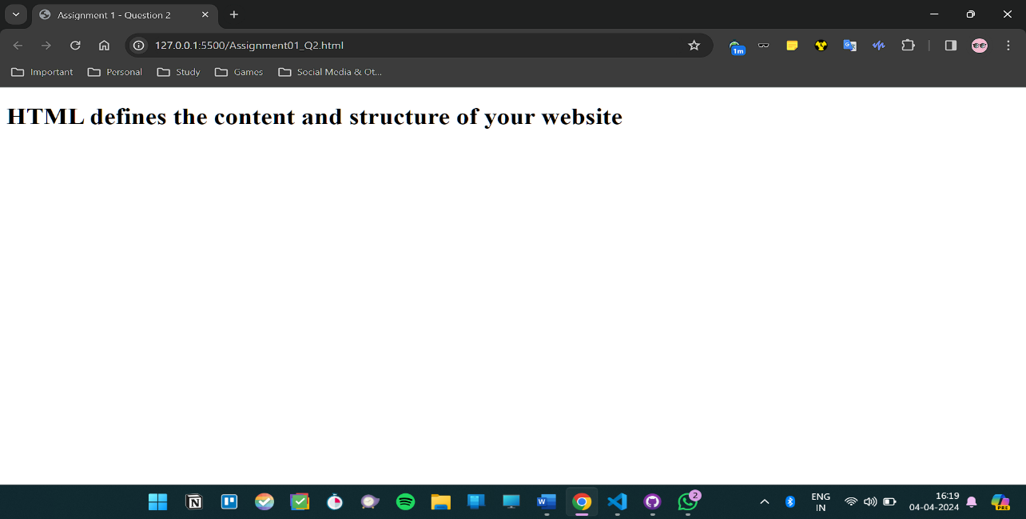

**Remark:** As we can see in the output the comments are not printed in the web page as expected.

**Code GitHub link:** [**Assignment 01 - Q2 Link**](https://github.com/Sunandanshrm/Web-Development/blob/master/Frontend/PwSkills/Assignment%2001/Assignment01_Q2.html)

**3.** The HTML code to display which includes a heading, a paragraph of text, a horizontal line, and a line break arranged in a simple web layout is as follows.

**The Code:**

<!DOCTYPE html>

<html lang="en">

<head><meta charset="utf-8">

<meta name="viewport" content="width=device-width, initial-scale=1.0"></head><head><title>

Assignment 1 - Question 3

</title>

</head><body>

<h1>The Website</h1>

<main>

<p>This is some text in a paragraph 1</p>

<hr><!--This is the horizontal line-->

<p>This is some text in paragraph 2

<br><!--This is a line break-->

This is the rest of the paragraph 2 after line break

</p>

<hr>

</main>

<footer>

<p>&copy; 2024 New Website</p>

</footer>

</body></html>

**The Output:**

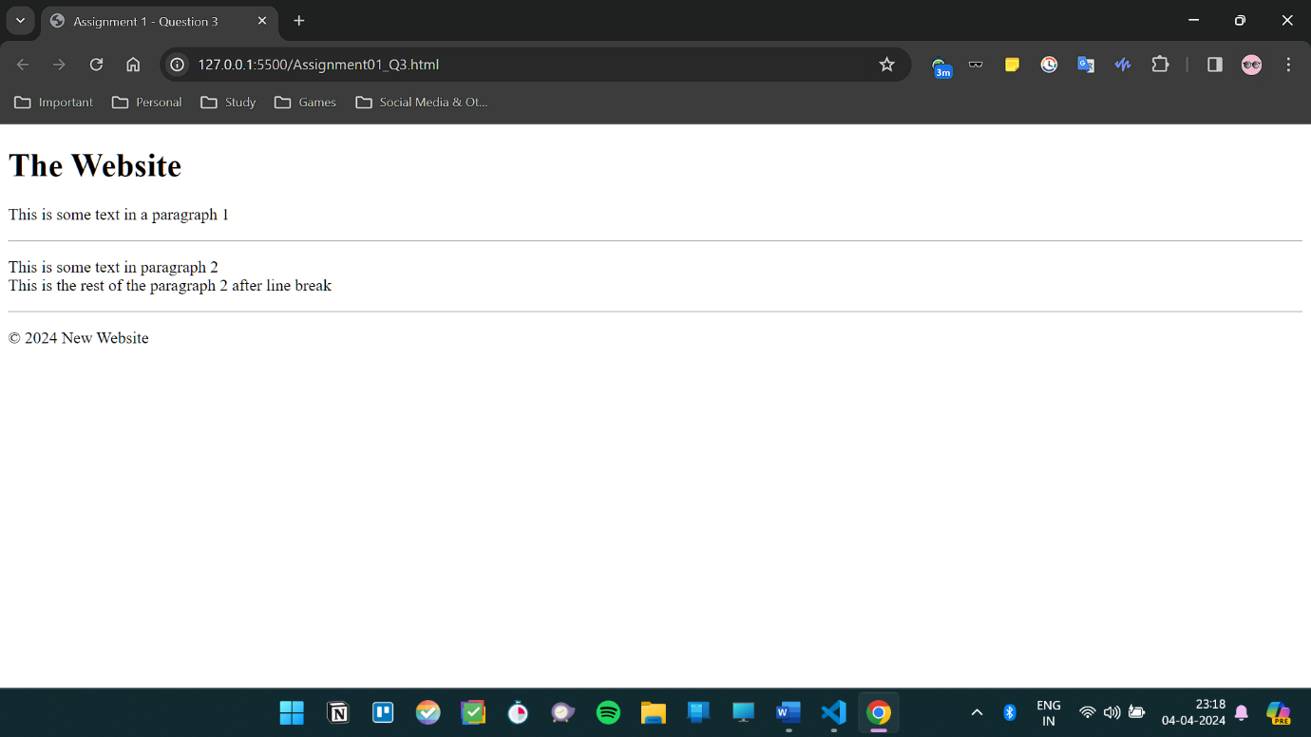

**Code GitHub link:** [**Assignment 01 - Q3 Link**](https://github.com/Sunandanshrm/Web-Development/blob/master/Frontend/PwSkills/Assignment%2001/Assignment01_Q3.html)

**4. HTML Tags:** HTML tags are keywords that help the browser understand how to format and display the page. It is generally denoted by angled brackets.

<title>: This tag denotes the title of the HTML document.

<h1>, <h2>, <h3>: This tag denotes the header of the HTML document. Different numbers denote the size of the font.

**HTML Elements:**  HTML elements are information enclosed by HTML tags which gets displayed by the browser. For example, “<p>This is some text in a paragraph 1</p>” is the paragraph element which is enclosed by paragraph (<p>) open and close tags.

**5.** <!Doctype HTML> is the preamble at the top of HTML file which tells the browser which version of HTML this file is therefore resulting in proper processing by the browser.